SMART FLOOR CLEANING SYSTEM

1st Shivakumar k v   
Electronics and communication engineering  
Alva's institute of engineering and technologyMangalore, India  
[4al21ec079shiva@gmail.com](mailto:4al21ec079shiva@gmail.com)

2nd Shashank Swamy

Electronics and communication engineering

Alva's institute of engineering and technology

Mangalore, India

[4al21ec077@gmail.com](mailto:4al21ec077@gmail.com)

3rd Prasanna Kumar B.I

Electronics and communication engineering

Alva's institute of engineering and technology

Mangalore, India

[4al21ec064@gmail.com](mailto:4al21ec064@gmail.com)

4th Shashank Viresh Sheeti

Electronics and communication

engineering

Alva's institute of engineering and

technology

[4al21ec078@gmail.com](mailto:4al21ec078@gmail.com)

5th prof. Sudhakara H M

Electronics and communication

engineering

Alva's institute of engineering and

technology

[sudhi123@aiet.org.in](mailto:sudhi123@aiet.org.in)

***Abstract***—**The smart floor cleaning system represents an advanced technology which enables automated floor maintenance with increased operational efficiency. The system executes self-cleaning operations using advanced technology like robotic sensors, and artificial intelligence. The device contains multiple sensors which enable its ability to identify environmental obstacles and complex terrain while recognizing different types of surface contamination. Through sophisticated algorithms, the system optimizes the cleaning operations and reads different types of flooring surface requirements. Users can control the system remotely in addition to scheduling cleanings and monitoring operations through mobile applications. The automated system lowers human work while improving cleaning performance and maintaining higher hygiene levels in domestic and commercial environments. Integrating IoT (Internet of Things) technology enables data collecting and analysis. Enabling ongoing improvement in cleaning performance and energy efficiency. This abstract introduces the smart floor cleaning system, including its major components and possible benefits in modern cleaning operations.**

***Keywords***—*Arduino Uno, Servo motor, Motor driver L298N, Water Pump, DC Motors, Bluetooth Sensor HC-O5*

# **INTRODUCTION**

Cleaning is a necessary duty, but many people disregard it because of their hectic schedules. Using traditional cleaning procedures can be time-consuming and exhausting. However, cleanliness is critical for physical health, emotional well-being, and productivity. To solve this, novel cleaning methods, particularly floor scrubbers, have been created. Previous models had drawbacks like inefficiency and intricate wiring, making them difficult to use. Now, the smart floor cleaning system provides a significant leap by operating autonomously, removing the need for human cleaning. This equipment saves time, effort, and energy by completing dry cleaning operations

simultaneously. Many individuals struggle to clean their houses every day, but this approach allows them to maintain cleanliness easily. A clean atmosphere lowers dust and germs, resulting in a healthier and more pleasant space while lowering stress. The method delivers businesses an inexpensive solution to office cleaning that avoids extra staffing costs. Smart technology simplifies cleaning operations to reduce both duration and enhance operational speed.

The advancement of technology enables the smart floor cleaning system to improve hygiene standards and simplify daily operations, thus freeing people to concentrate on their work, family life, and personal interests. The development of technology determines how people perform cleaning duties in their homes and workplaces. The smart floor cleaning system presents a perfect example of advanced technology. It makes cleaning easier, faster, and more effective. It conserves time, energy, and effort. It also promotes good hygiene and overall well-being. In the future, more advanced cleaning technologies could be created. These advancements will continue to make life simpler. The idea is to lessen the amount of housekeeping. This allows people to relax and enjoy their time without having to tidy up. The smart floor cleaning technology is a step toward a more convenient and efficient future. This technique frees people from the pressure of domestic tasks by expediting the cleaning process, allowing them to focus on other important things like jobs, family time, or personal interests.

1. **LITERATURE SURVEY**

The robot comes equipped with a tiny vacuum cleaner for dust collection and a motorized mop that cleans the floor with water. The author emphasizes the ease of emptying the vacuum after cleaning. Future advancements, such as mapping technology, may increase the robot's capacity to clean every area of space effectively. The author's goal with this project is to create a basic yet effective robotic solution for automatic floor cleaning [1].

The author explores how modern science continues to improve in ways that make daily life simpler. One such innovation is the Smart Floor Cleaning Robot, which is intended to automate floor cleaning efficiently. The author highlights the significance of cleaning and hygiene, pointing out that busy lifestyles frequently leave people with little time for housework. This robot addresses that issue by providing remote control capabilities via a built-in Wi-Fi module [1].

The author outlines the creation of a smart cleaning robot designed to ease and automate household cleaning activities. Major purpose of robot is to decrease human involvement in cleaning process. Proposed system includes mopping as well as vacuuming functions. The mopping component comprises a mop that is attached to a tiny water container, allowing it to stay wet for excellent floor cleaning. Meanwhile, the vacuum portion has a vacuum pump that captures dust particles. An Arduino Mega microcontroller manages the entire system, including hardware and software activities [2].

A GSM module is used to allow the robot and the user to communicate wirelessly. Upon activation and when mop needs to be replaced, the robot gives user an acknowledgment message. Users can choose between dry and wet cleaning modes depending on their preferences. Users can activate the robot either through external buttons or by using the remote-control function. The robot implements both cleaning functions and obstacle detection features to perform cleaning tasks effectively under user control [2].

The author investigates smart floor-cleaning robot applications across residential, airport-terminal, hospital, public transit station, shopping centre, and commercial facility environments. Modern robotic cleaning devices perform the tasks previously done with traditional brooms and mops because these machines boost operational efficiency while minimizing human involvement. An Arduino controller serves as the platform for robot implementation through which it oversees its operational tasks [3].

The robot system performs different cleaning tasks, including sweeping and mopping, dust removal, and sanitization operations. The system operates without human assistance to maintain floor cleanliness. After activation, the robot performs cleaning operations throughout the house which removes the requirement for human labour. The equipment operates independently, which makes it a useful and effective solution for modern cleaning requirements [3].

The author discusses how science and technology progress rapidly to develop methods that enhance human comfort. Primary objective of current research is to develop automatic Smart Floor Cleaner that runs through an Android device control. The robot system aims to cleanse different surfaces such as floors and upholstery and draperies with high efficiency [4].

The system incorporates a controller that powers the motors and suction unit, as well as sensors that identify and avoid obstructions. This idea intends to improve an individual’s quality of life (QoL) by lowering amount of effort required to clean. Researchers are increasingly interested in robots as they try to make everyday living more convenient and efficient, thanks to constant technological improvements [4].

The author analyzes the impact of robotics on human life, highlighting how technological improvements have made daily jobs easier and more convenient. This study describes a low-cost smart cleaning robot designed for people who do not have access to high-end robotic solutions. While there are several autonomous cleaning robots on the market, they all perform well based on their capabilities, but none are economical [5].

The suggested system includes a transmitter application that runs on an Android mobile app and allows the user to control the robot using communicated instructions. The system operates through an Arduino UNO microcontroller that possesses fourteen input/output pins together with cleaning functionality and robotic arm capabilities. Instructions received from the Android device through a Bluetooth receiver make the microcontroller perform decoding operations that lead to motor control for movement of the robot [5].

1. **METHODOLOGY**

The smart floor cleaning system aims to automate cleaning operations through modern components, providing users with efficient and convenient functionality. The operating mechanism of this system depends on an Arduino Uno microcontroller, which serves as the processing centre that connects various sensors and motors to the cleaning components. The system functions using rechargeable batteries that integrate multiple ultrasonic sensors with an infrared sensor and motor driver and Bluetooth Low Energy (BLE) module. The positioning of ultrasonic sensors enables the system to detect cleaning path obstacles leading to decreased accidents and a smooth operational flow. The detection quality of the IR sensor improves because it identifies floor surface variations alongside dirt which allows the system to effectively control its cleaning power.

Users establish wireless BLE connectivity to control and monitor cleaning system operations from their mobile phones and external devices. The control system of the motor driver enables management of the cleaning operations by controlling motors M1, M2, M3 and M4.

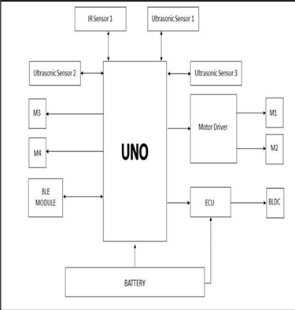

Figure 1: proposed system overview

The device operates independently through its long-lasting rechargeable battery power supply. During operation, the cleaning system uses sensors to steer through surfaces while moving across the target area. A mix of motorised brushes with suction capabilities successfully removes dust together with dirt and stains from floor surfaces. This device operates effectively on both dry and wet surfaces, which allows its usage in residential homes, business spaces and workplace environments.

Users can customise cleaning schedules together with settings through their mobile application for a device that adapts to personal requirements. The intelligent navigation system of this technology creates maps for cleaning spaces, which helps optimise routes so operations become more efficient and reduce repetition. The automated system reduces the requirement for human involvement which results in better convenience alongside increased time efficiency. The smart floor cleaning system offers its best benefits to users who have busy lifestyles, and seniors, alongside organisations that require economical maintenance solutions. The automated cleaning solution needs less human labor yet delivers higher cleaning efficiency than conventional cleaning approaches. The small dimensions enable it to reach areas such as corners and tight spaces.

Difficult to clean by hand. Real-time monitoring through Bluetooth connectivity lets customers check cleaning progress and battery status from any location. The technology improves cleaning standards and simultaneously improves the living environment through its ability to reduce allergens and bacteria levels. Modern technology will establish smart cleaning devices as essential components for enhancing residential and business cleaning solutions. The smart floor cleaning system brings users a friendly interface and efficient operation and automatic functionality to create smarter and more convenient cleaning processes. The system moves effortlessly through different surfaces.

The BLDC motor in the system provides Brushless DC (BLDC) power to enhance both suction and scrubbing operations for improved cleaning results. The Electronic Control Unit (ECU) distributes power to different components through its control system for both efficient energy usage and extended system lifetime. The Smart Floor Cleaning System flowchart shows how the system performs its autonomous cleaning through multiple sensors combined with motors and communication elements. The system starts its operation when the power is turned on during the Start phase.

The Arduino Uno activates all required modules through Initialising Components to enable proper configuration of ultrasonic sensors, an IR sensor, a motor driver, a Bluetooth module, and battery power distribution. The system proceeds to Sensor Data and Bluetooth Command Processing after completing initialization.

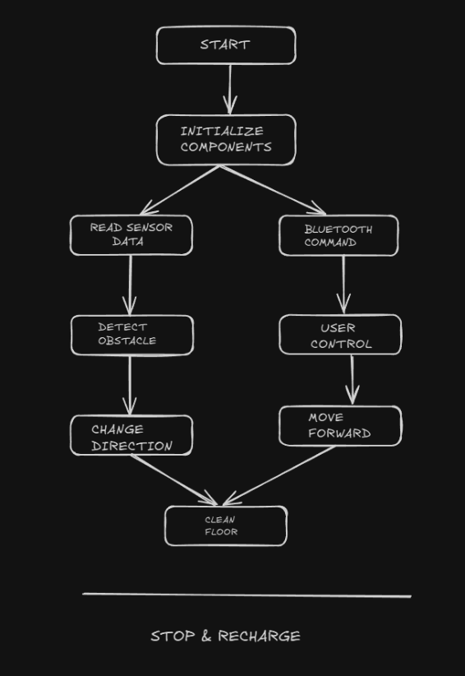

Figure 2: Flowchart of the proposed system

The system uses ultrasonic sensors and infrared sensors to monitor environmental data and identify obstacles, then evaluates floor conditions and the Bluetooth module scans for user commands. The system provides User Control when a Bluetooth Command arrives so the user can navigate manually through their smartphone or remote device. At independent operation, the system uses Detect Obstacle to identify potential obstacles. Decision point. The system will execute the Change Direction function when it detects an obstacle to modify the path trajectory for collision avoidance. The system moves forward with its cleaning procedure when no obstacles are present. The cleaning process during the Clean Floor phase achieves successful results through the combined use of motorised brushes and suction mechanisms despite the chosen navigation method. The machine operates in either dry or wet cleaning modes depending on user selection or floor condition requirements.

The system will operate continuously until it needs to recharge. The automated obstruction detection system protects safety operations by stopping collisions with furniture and avoiding unnecessary stops. The developed methodology leads to superior automation of residential and industrial cleaning operations and establishes a framework for self-sufficient intelligent cleaning systems. Technology advancements will help AI and machine learning improve this system, enabling it to learn while it operates for better navigation achievements and cleaning precision. The Smart Floor Cleaning System represents an advanced cleaning technology that unites automated processes with human management to deliver successful, hassle-free cleaning operations.

|  |  |  |
| --- | --- | --- |
| **S/N** | **Components** | **Quantity** |
|  | Arduino Uno | 1 |
|  | Servo motor | 3 |
|  | *Motor driver L298N* | 1 |
|  | Water Pump | 1 |
|  | DC Motors | 5 |
|  | Bluetooth Sensor HC-05 | 1 |
|  | Ultrasonic Sensor | 1 |
|  | Connecting Wires | As Required |
|  | Wheels | 4 |
|  | Rotating Cotton Bush | 1 |
|  | Vacuum Pump | 1 |

1. **IMPLEMENTATION**
2. ***Software Implementation:***

The software implementation for this project runs through the Arduino IDE using C/C++ programming language. The hardware interface becomes simpler because the project uses essential libraries including 'Servo.h' for servo motor control and 'SoftwareSerial.h' for Bluetooth connectivity. The system includes a Bluetooth controller that allows wireless command transmission through both custom Android apps and Bluetooth Terminal. The Arduino receives commands through its Bluetooth module which are processed before executing them to operate connected components. The Bluetooth connection allows immediate data exchange between mobile devices and Arduino, which drives the automated system. The software system evaluates incoming commands to operate servo motors alongside DC motors and water pumps thus ensuring the system operates effectively and in real-time.

1. ***Hardware Implementation:***

The hardware implementation of the project combines multiple elements, which an Arduino Uno microcontroller oversees to execute commands and direct hardware operations. The servo motor executes accurate angular movements to operate valves while changing specific positions. Through PWM signals from Arduino, the L298N motor driver controls direction and speed of DC motors. A water pump operates within the system yet the relay module and MOSFET enable users to control its operation for fluid management. The Bluetooth module HC-05 enables wireless connectivity between Arduino and mobile devices for remote control and real-time data exchange to enhance system operation efficiency while motors serve robotic and mechanical applications because of their movement capabilities.

**V. RESULT**

An autonomous floor cleaning robot received control through an Arduino Uno microcontroller during its development process. The robot incorporates DC motors for mobility together with ultrasonic sensors and IR sensors for detection and navigation capabilities as well as a Bluetooth module and cleaning elements comprising brushes and suction. Both wet and dry-cleaning functions are available within the system. Sensors enable the device to create mapping data of its surroundings, prevent collisions, and generate efficient cleaning routes. People can operate and track the robot through their smartphone application.

Key advantages include:

-Cleaning process requires less manual work while saving time for all cleaning duties.

-Robot system enables more efficient cleaning operations with standardised results.

-This device enables cleaning in limited spaces along with reaching confined areas.

- Cost-effective solution for homes and businesses

-System helps improve hygiene conditions by minimising allergens as well as bacteria.

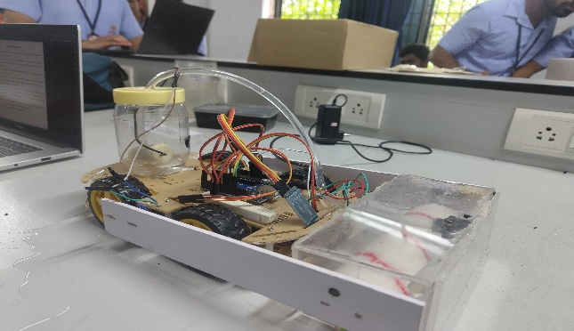

1. **CONCLUSION**

The Smart Floor Cleaning System presents an attractive solution to automate basic household maintenance through floor cleaning operations. The Smart Floor Cleaning System functions precisely through the combined capabilities of Arduino UNO microprocessor, L298N motor driver, HC-05 Bluetooth module, and servo motors and water pump. The servo motors control both arm lifting operations and manual manipulation, which makes the cleaner suitable for cleaning diverse surfaces. The water pump system extends the cleaning capacity by enabling the system to spray water effectively, removing all dirt and other particles. The system enables easy control through mobile application because of its built-in Bluetooth functionality.

The project consists of essential design considerations which include energy conservation together with cost optimization and user-friendly features. This system serves as a viable automation solution for home and small business floor maintenance because it utilizes basic and affordable materials. The system operates with ease, which enables both technical novices and experienced users to operate it effectively. The system shows potential for improvement through future development to add functions including automatic obstacle detection, self-route generation and multi-surface cleaning. Research development on the Smart Floor Cleaner could result in a completely independent robotic cleaner that adapts to various environments while cleaning surfaces, proving to be key innovation in home automation. People may experience better quality of life as the Smart Floor Cleaning System offers priceless benefits from the Internet of Things and automation technology. The technology serves as an indicator for the development of intelligent homes which merge various aspects of technology into standard domestic activities.

1. **REFERENCE**
2. Indronil Dey Niloy, Sayed Mohaiminul Hoque, Mashfiqul Hoque, Afif Bin Arfan, Israt Jahan, Islam Bin Mursalin, Mohammad Shidujaman, Mohammad Rejwan Uddin, and Mahady Hasan. "Smart Floor Cleaning Robot." Fab Lab IUB, Independent University, Bangladesh.DOI:10.1109/TENSYMP55890.2023.10223665. Published on ResearchGate: <https://www.researchgate.net/publication/373709780>.
3. Sharada L. Kore, et al. "Floor Cleaning Smart Robot." International Journal of Sharada L. Kore, et al. "Floor Cleaning Smart Robot." International Journal of Engineering Research and Applications (IJERA). ISSN: 2248-9622, Vol. 12, Issue 9, September 2022, pp. 61-65. Department of E&TC, BVCOEW, Pune, Maharashtra, India. Published on IJERA:

www.ijera.com.ResearchGate:https://www.researchgate.net/publication/363503605.

1. Prof.Dattatray M. Kumbhar, Mrs.Vidya Shetti. "Smart Floor Cleaning Robot." Journal of Emerging Technologies and Innovative Research (JETIR). ISSN: 2349-5162, Volume 7, Issue 10, October 2020. E&CE Department, HSIT, Nidasoshi, Karnataka, India. Published on JETIR: [www.jetir.org](http://www.jetir.org).
2. Pooja D. Rathod, Puja V. Wandile, Kiran S. Mohitkar, Pallavi G. Jiwtode. “Multipurpose Smart Floor Cleaning System by Using Android Device.” International Journal of Scientific Research in Science, Engineering and Technology (IJSRSET). Print ISSN: 2395-1990, Online ISSN: 2394-4099, Volume 4, Issue 7, 2018. Electrical Engineering Department, Datta Meghe Institute of Engineering, Technology and Research, Salod (Hirapur), Wardha, Maharashtra, India. Themed Section: Engineering and Technology. Published on IJSRSET.
3. Shritika Walker, Prashant Tiwari, Vishal Kumar, Kunal Limbu, Amay Tawade. "Smart Floor Cleaning Robot Using Android." Department of Electronics and Telecommunication, Dr. D.Y. Patil Institute of Engineering, Management and Research, Akurdi, Pune, Maharashtra, India. International Journal of Engineering Research & Technology (IJERT). E-ISSN: 2395-0056, p-ISSN: 2395-0072, Volume 09, Issue 01, January 2022. Published on IJERT